Piano Hero Overview Diagram



[This Photo](https://commons.wikimedia.org/wiki/File:Wireless-icon.svg) by Unknown Author is licensed under [CC BY-SA](https://creativecommons.org/licenses/by-sa/3.0/)

Wav to MIDI Conversion Service

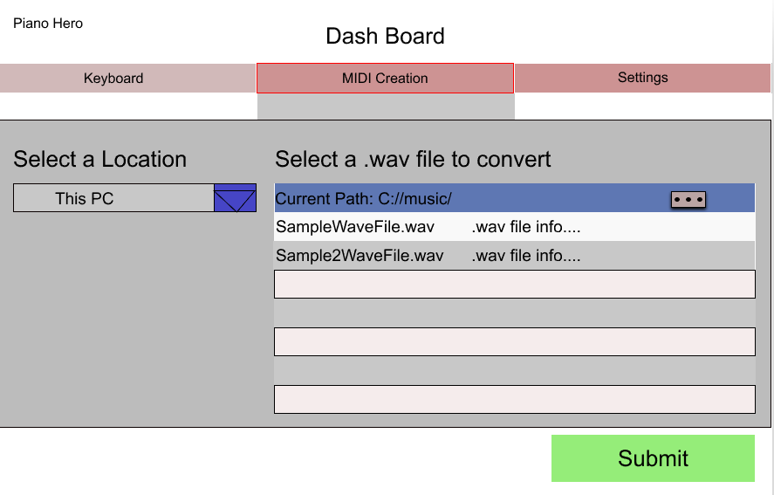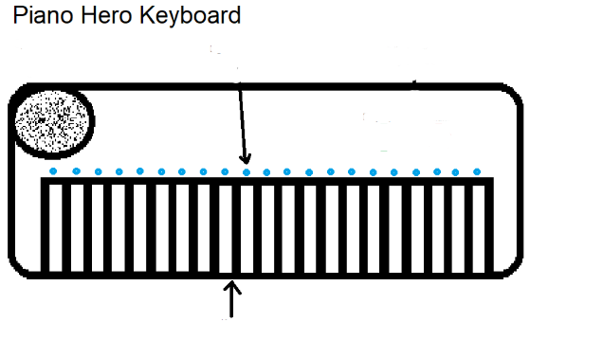

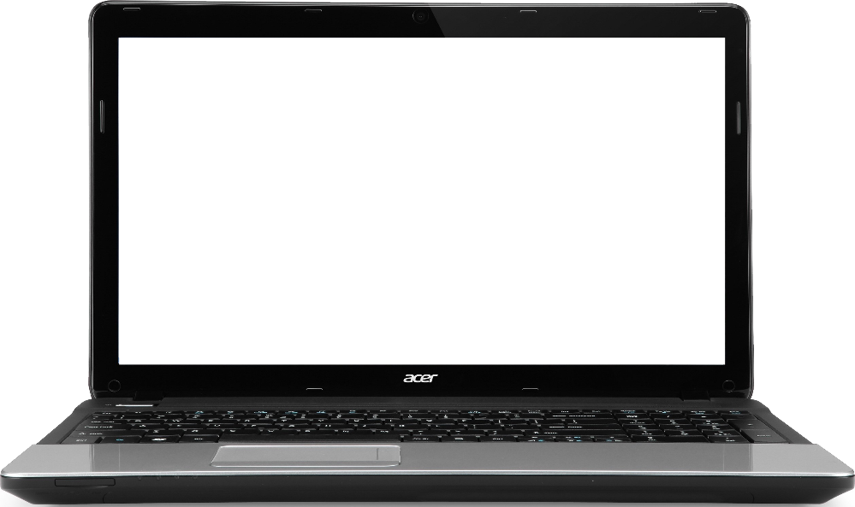

[This Photo](http://pngimg.com/download/5938) by Unknown Author is licensed under [CC BY-NC](https://creativecommons.org/licenses/by-nc/3.0/)



[This Photo](https://commons.wikimedia.org/wiki/File:Wireless-icon.svg) by Unknown Author is licensed under [CC BY-SA](https://creativecommons.org/licenses/by-sa/3.0/)

WiFi Router



[This Photo](https://commons.wikimedia.org/wiki/File:Wireless-icon.svg) by Unknown Author is licensed under [CC BY-SA](https://creativecommons.org/licenses/by-sa/3.0/)

Microcontroller

LED Strip, one light per key

Keys